HCI H2 Math Prelim Paper 2 Solution

Qn. | Solutions
1  (i) |   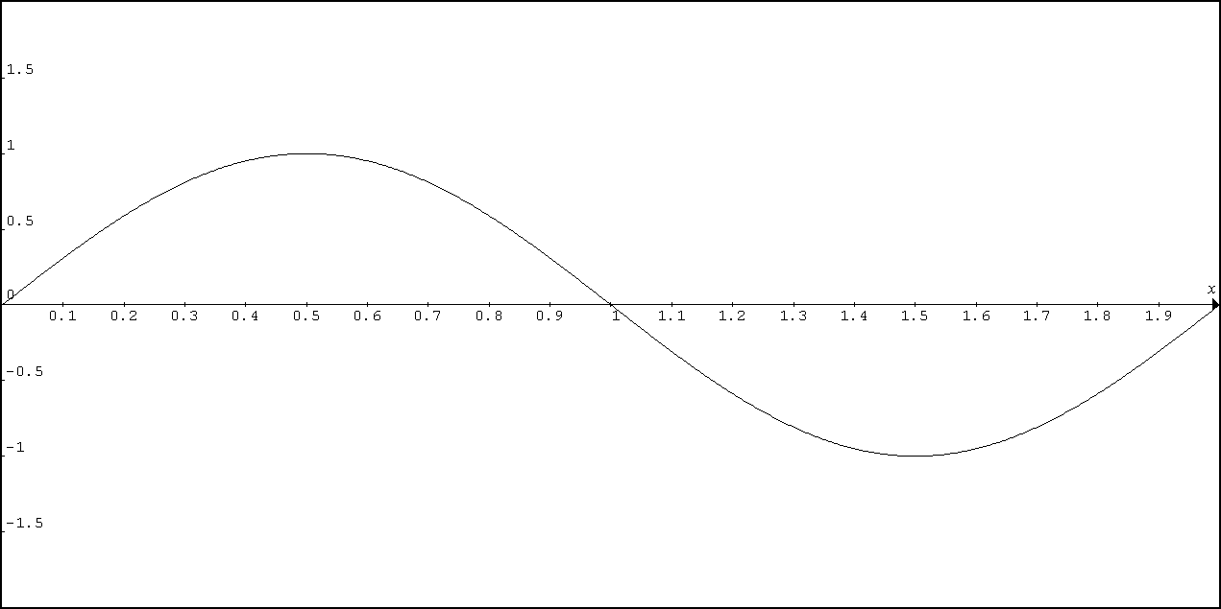  Since y = 0.5 cuts the graph twice, f is not a one-one function. Therefore 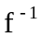 does not exist.  Restrict the domain to 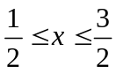 so that the range of h is equal to the range of f.  m = 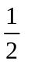 , n = 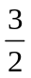  Since h() = , therefore 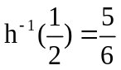.
(ii) | With domain ,  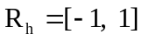, 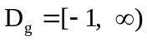,  Since 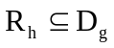, therefore gh exists.  Substituting 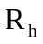as 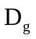 into y = g(x) graph,  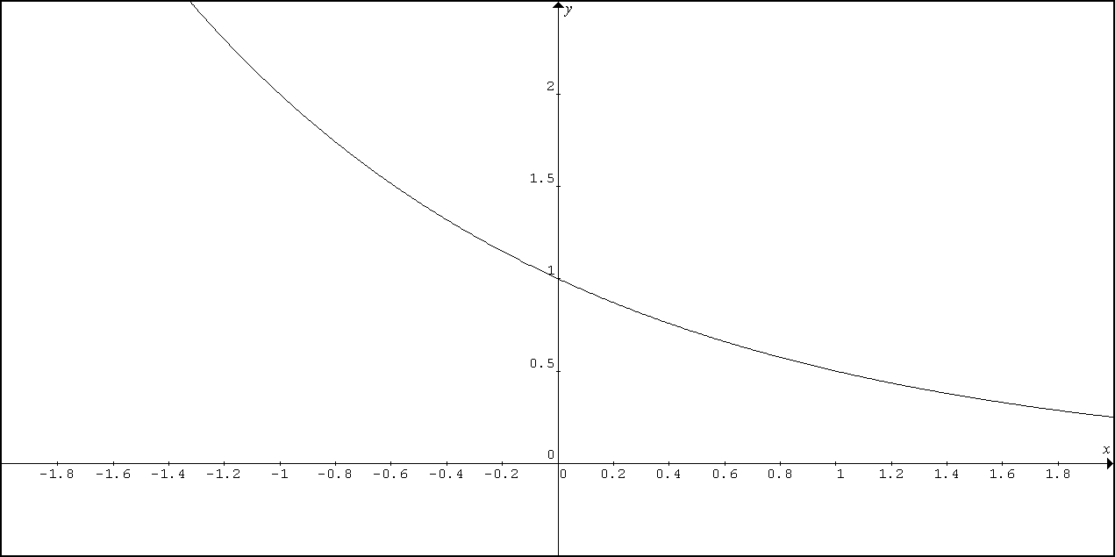  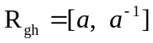
2 | Let w be the width of the paper used and h be the length of the paper used.  Area of paper used, A = wh  We have 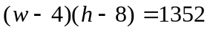  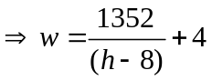  Therefore 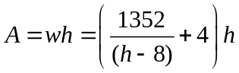  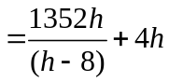  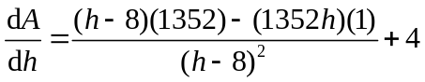  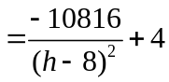  To minimise the paper used,  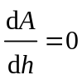  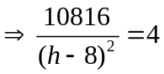  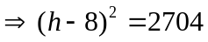  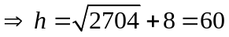  First derivative test:  OR  Second derivative test:  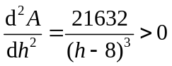  Hence at 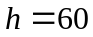, the amount of paper used is minimised.  At ,  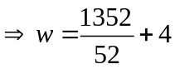  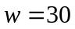  Hence the dimension of the paper is 30 cm by 60 cm.
  h | 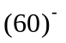 | 60 | 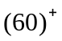
  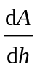 | -ve | 0 | +ve
3  (i) | 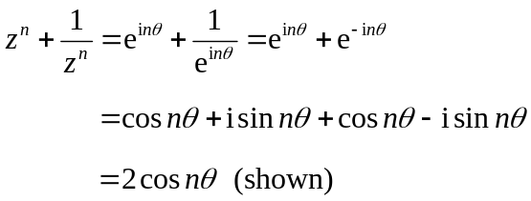
(ii) | 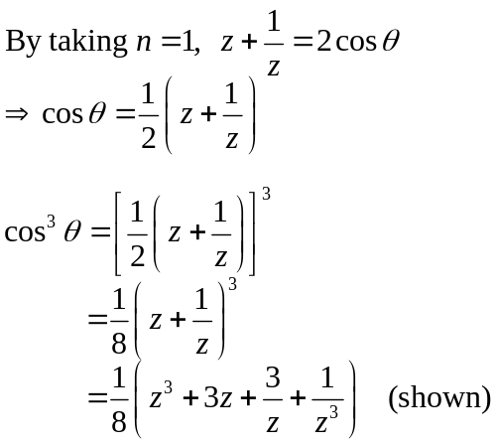  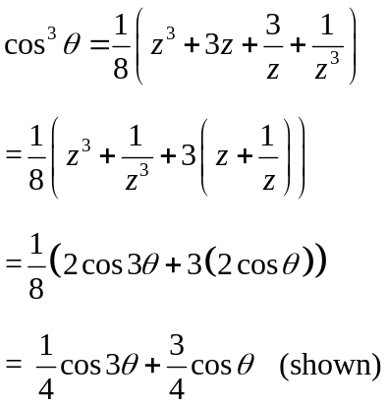
(iii) | Method 1  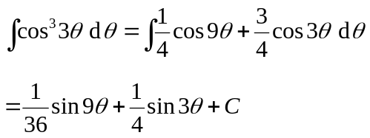  Method 2  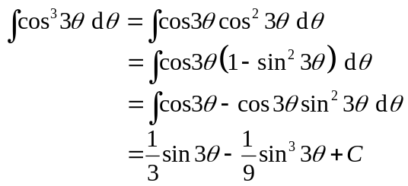
4  (a) | 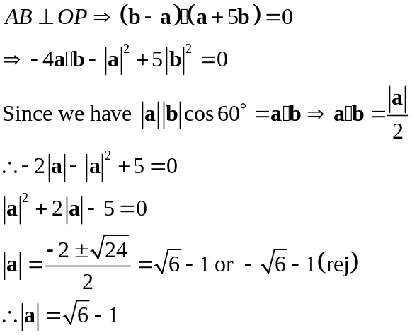
(b) | 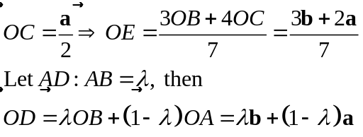  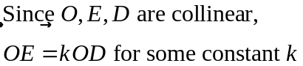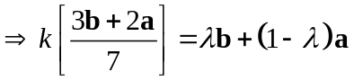  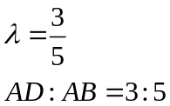
5  (i) | For x > 0, 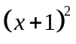 > 0  Since a, b and c are positive, for x > 0,  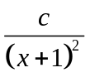 > 0 and 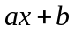 > 0  ∴ 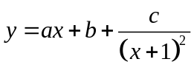 > 0 for x > 0 (shown)
(ii) | Given area of region R = 42  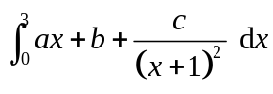 = 42  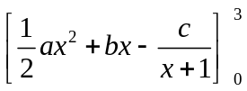 = 42  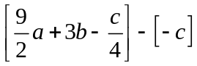 = 42  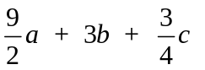= 42 (shown) ⎯⎯ (1)
(iii) | At (0, 5), 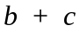 = 5 ⎯⎯⎯⎯⎯ (2)  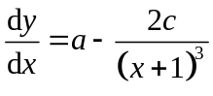  At (0, 5), 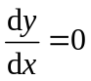  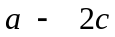 = 0 ⎯⎯⎯⎯⎯ (3)  From GC, 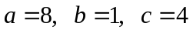  ∴ equation of G is 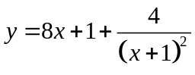.
(iv) | 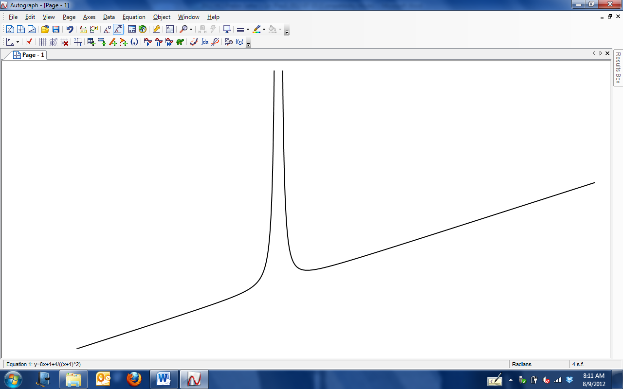  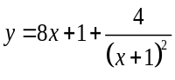  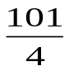  x  y  0  y = 8x + 1  x = −1  (−1.59 , 0)  (0, 5)  x = 3  R  S  [Note: x-intercept (−1.585171 , 0)]
(v) | Required volume  = 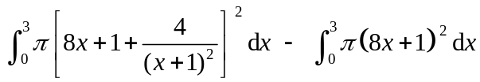  = 163.2774895  = 163 units³
6(i) | Let X be the time spent by a customer at a supermarket.  If 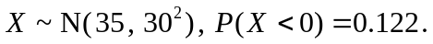  i.e. the probability that the time spent being less than zero is significantly big.  However, X is a non-negative quantity. Therefore a normal distribution will not provide an adequate model.
(ii) | Let X be the time spent by a customer at a supermarket.  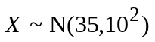  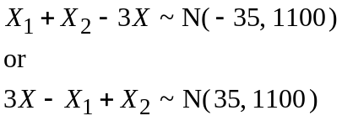  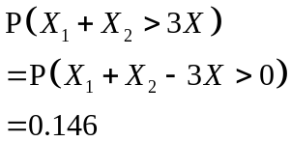
7(i) | No. of ways 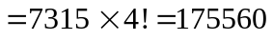
(ii) | 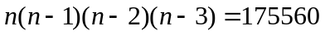  or 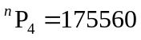 or 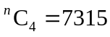  Using GC or guess and check, 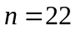.  seat  seat  seat  seat  seat  Method 1:  Consider the 4 scholarship recipients as 1 unit.  7 ways to slot the 4 scholarship recipients.  4! ways to arrange scholarship recipients among themselves.  9! ways to arrange remaining applicants.  No. of ways 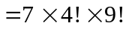  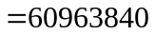  Method 2:  Consider the 4 scholarship recipients as 1 unit.  Case 1: The 4 scholarship recipients are in the row with 6 seats.  Case 2: The 4 scholarship recipients are in the row with 7 seats.  7! ways to arrange remaining applicants in row with 7 seats.  No. of ways  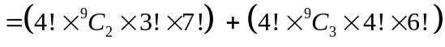  4! ways to arrange scholarship recipients among themselves.  3! ways to arrange 1 unit of scholarship recipients and 2 non-scholarship recipients.  ways to choose 2 non-scholarship recipients in row with 6 seats.
8(i) | 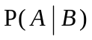  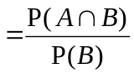  = 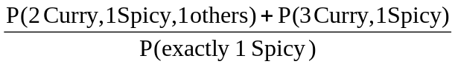  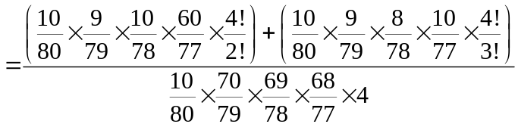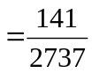 or 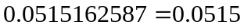 (3 s.f.)  OR  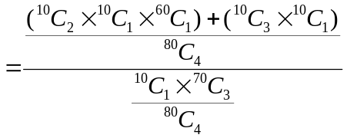  or (3 s.f.)
(ii) | 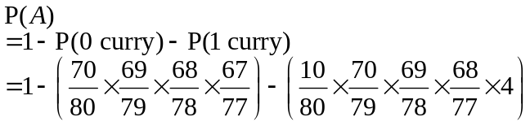  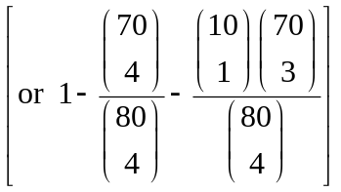  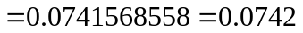 (3 s.f.)  Or  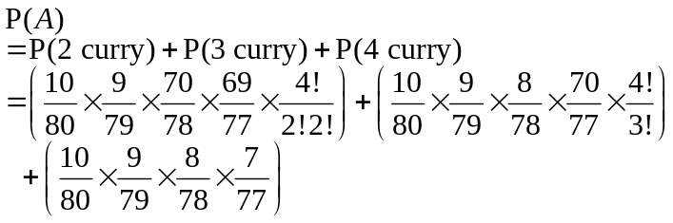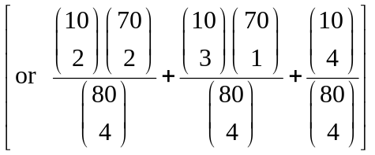  (3 s.f.)  Method 1:  Show 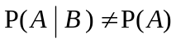. Hence A and B are not independent, and 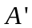 and 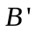 are not independent.  From (i), 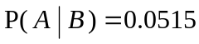  Since 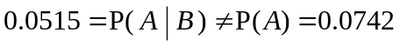,  A and B are not independent.  Hence and are not independent.  Method 2:  Show 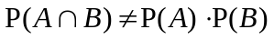. Hence A and B are not independent, and and are not independent.  From (i), 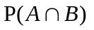  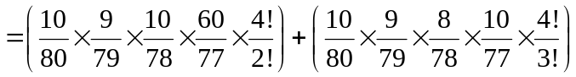  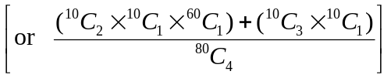  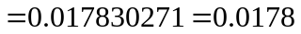 (3 s.f.)  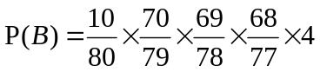  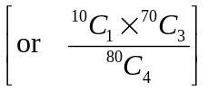  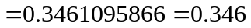 (3 s.f.)  Since ,  A and B are not independent.  Hence and are not independent.  Note: Students can choose to show 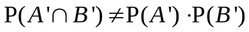 or  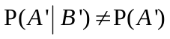 or  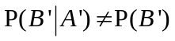
9(i) | Let X be the number of defective SIM cards, out of 10.  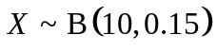  We assume that the probability of a SIM card being defective remains constant at 0.15. OR  We assume that the defective SIM cards produced are independent of one another.
(ii) | 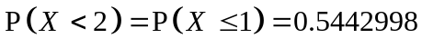  Let Y be number of ‘good’ batches, out of 33.  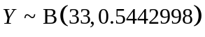  Since n = 33 is large, np = 17.962 > 5,  n(1–p) = 15.038 > 5,  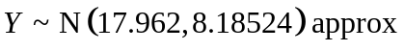  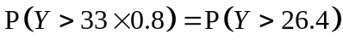  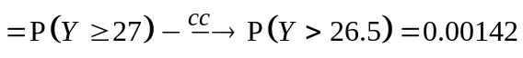
10  (a)  (i) | The customers are ordered as they queue up at the payment counter.  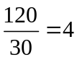  The first customer is chosen from the 1st four customers using simple random sampling.  Every 4th customer is chosen thereafter.
(ii) | No. As we cannot gather the profile of the customers and break down into strata proportional to that of the 120 customers as the survey is done before the customers leave.
(b) | Let X be the waiting time.  Since n = 100 is large, by CLT,  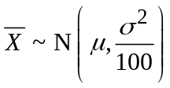 approximately.  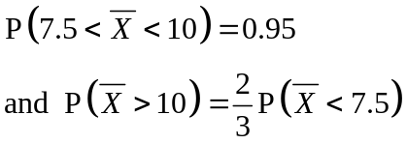  7.5  10  2x/3  μ  x  0.95  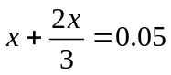  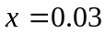  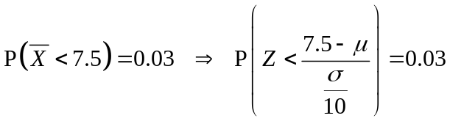  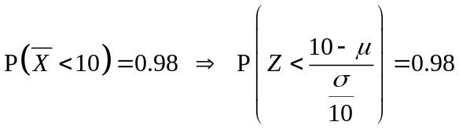  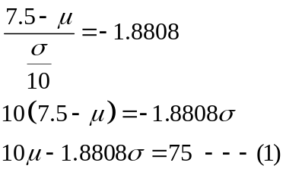  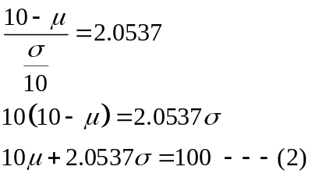  Solving (1) and (2), 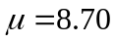
11  (i) | Let T be an estimator of the population variance . Then T is an unbiased estimator of if 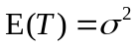.
(ii) | Using GC,  An unbiased estimate of mean of X,  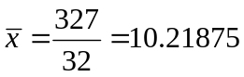 (exact)  An unbiased estimate of variance of X, 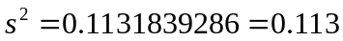 (3 s.f.)  GC keystrokes:  v>5:Statistics…>3:S_{x}  q
(iii) | Assumption: X follows a normal distribution.  Let  mm be the population mean diameter of a miniature wheel.  H₀ : 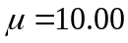  H₁ : 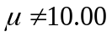  Test statistic: T 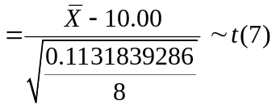  Level of Significance: 10%  Critical region: Reject H₀ if p-value 0.10  Assuming H₀ is true, using GC,  p–value = 0.10849  Since p-value = 0.10849 0.10, we do not reject 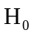at the 10% level of significance and conclude that there is insufficient evidence that the mean diameter of the miniature wheel is different from expected.
(iv) | H₀ :  H₁ : 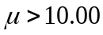  Test statistic: 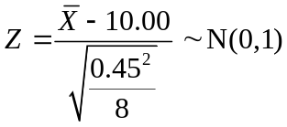  Level of Significance: 5%  Critical region: Reject H₀ if p-value 0.05  i.e. Reject H₀ if 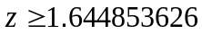  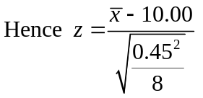≥ 1.644853626  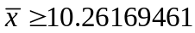  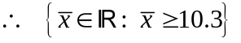
12  (i) | w  E  20  0  180  107  209
(ii) | The scatter diagram seems to indicate a curvi-linear relationship between the points. Hence the linear model 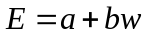 is probably not appropriate.
(iii) | For w and 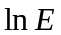,  For w and 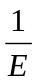, 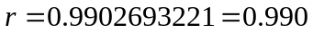  Since 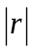 for w and is closer to 1, the formula 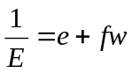 is a better model.
(iv) | The least squares regression line of on w is appropriate since w is the independent variable.  Using GC, the equation of the least squares regression line of on w is  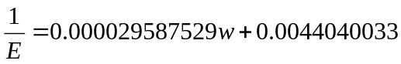  When 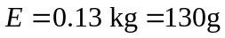, we have  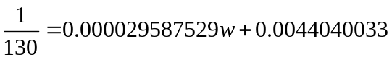  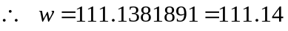ml
13  (i) | Let A be no. of accidents along NS line per week.  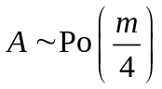  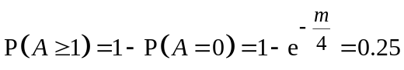  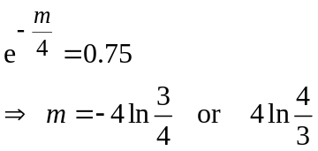
(ii) | 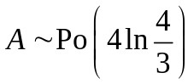  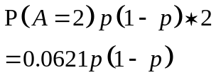
(iii) | Let B be no. of accidents along EW line per week.  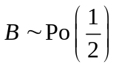  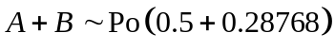  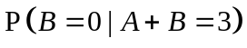  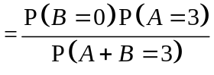  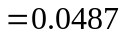
(iv) | Let C be the number of accidents along the EW line per month.  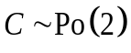  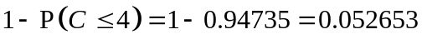  P(more than 52 months with at most 4 railway accidents) = P(less than 8 months with more than 4 railway accidents)  Let X be no. of months, out of 60, with more than 4 accidents. 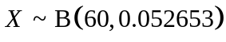  Since n = 60 is large and p = 0.052653 is small such that np = 3.1592 < 5. 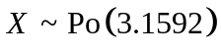 approx  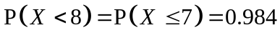  Note:  If we use P(more than 52 months with at most 4 railway accidents), than 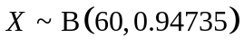and since p is large, Poisson approximation will fail.

